PRACTICAL WEEK – 6
TASK 1: Create a client-sewer application using Named Pipes (FIFOs). The client sends messages and the Server processes and responds to them. Analyze FIFO behavior when multiple clients communicate simultaneously.
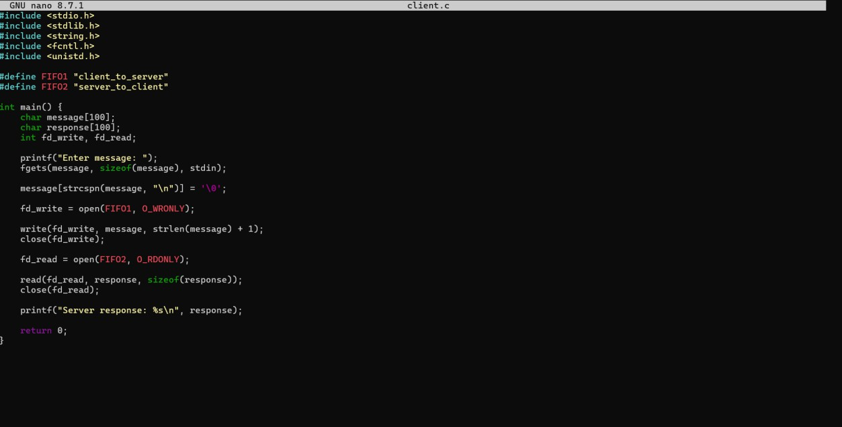
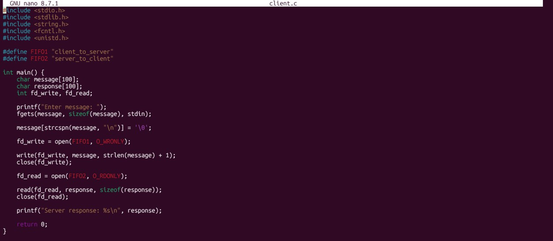
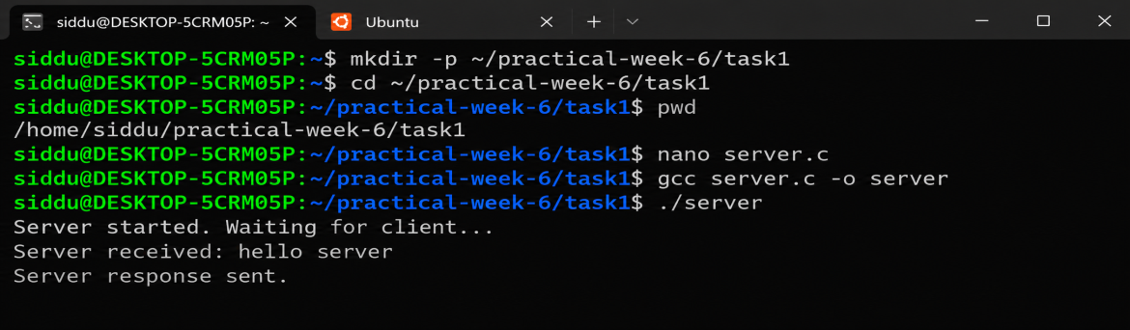

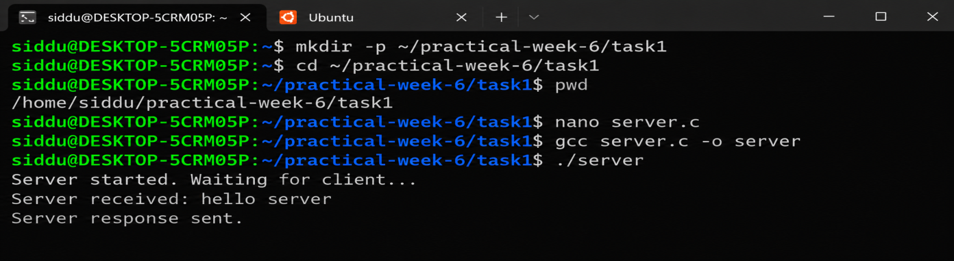

TASK 2: Create a POSIX signal handling program that captures SIGINT, SIGTERM, and SIGUSRI. Demonstrate asynchronous event handling and explain the role of signal handlers.
